YOUR NAME: _______________
Psychedelic Posters, Conceptual Image & Early Post Modernism
This worksheet is based on the reading from the book, “Graphic Design: A New History” pages 304 - 329.
There are 4 questions. Please fill this worksheet out. If you do not write full sentences then bullet point your answers. If it is a direct quote from the chapter, then include quote marks.

1. | What is postmodernism as it pertains to graphic design? Why is it difficult to define?
Postmodernism refers to a style and concept categorized by distrust of theories and ideologies of drawing attention to conventions. It is the assumption of science to explain the reality of people and how they think. It suggests that reality is not focused on human understanding but rather is constructed as the mind tries to understand its existence. Thus, postmodernism is doubtful in graphic design as its explanation claim to be valid for all aspects, including culture, tradition, group, or races, and lather focuses on each person's reality. It's difficult to explain it because individual artists explore pluralism which deals with cultural art at large i.e., Psychedelic, Push Pin, and Tibor Kalman.

2. | Discuss the psychedelic design movement in San Francisco and how it impacted Rock album covers across the US and Europe. Provide some examples.
Psychedelic design is a graphic design of rock style popular in the 1960s, primarily inspired by drugs like marijuana and LSD, thus reflecting drug-induced state through electronic, feedback, and intense volume. It became the dialogue of the more comprehensive culture exploration of the hippie movement on the west coast of the united states. These made it spread in San Francisco and the rest of the country and then to Europe, where it becomes the central rock phenomenon. It impacted the music style designs and improved dress, language, and the way people spoke. Examples of psychedelic design included; Concert posters, album covers, liquid light shows, liquid light art, murals, comic books, and underground newspapers.

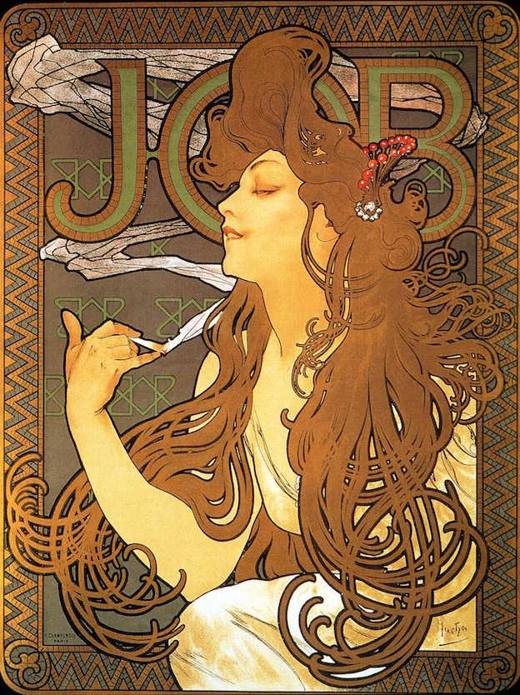

3. | Discuss several reasons why designers felt the need to reject some or all of the International Style.
First, they wanted to use ways to mix historical styles and use vernacular works in their designs to make their arts more interesting and coloring of their taste. They also rejected the international design and closed Bauhaus due to violence, intimidation & aggressive control of mass media. Designers felt styles that emerged after world war one emphasizes volume over mass characterized one, the use of lightweight, mass-produced, industrial materials, rejection of all ornament and color, repetitive modular forms, and the use of flat surfaces, typically alternating with areas of glass thus limiting some designers in innovation.

4. | Discuss the strengths and weaknesses of “conceptual design” as practiced by Push Pin Studios and other designers.
The conceptual design had a weakness as they used sensitive issues such as homelessness as public relations to get public attention. This brought about disconnections with the viewers and the inability to sell the product it was advertising. They focused on designs that mean something and connect to people at a human level. They also focused on multiculturalism and global awareness by using bold graphic design, typography, and doctored images. Some of their designers depicted racial minorities changing how the world was viewed and acting as social activists. The strength would be the uniqueness of the design. They believed that a good design must send a message that could lead to action and not be good designers, making them have strength in graphic design.

